Team Members:
- Mr. Ligade Akshay V.
akshay.ligade2@gmail.com
Mob: 7795676412
Stream Code: CPT
Branch: Information Science and Engineering.
College: SDM College of Engineering and tech. Dharwad.

- Miss. Shanta Kallur
kallurshanta@gmail.com
Mob: 9739442246
Stream Code: CPT
Branch: Information Science and Engineering.
College: SDM College of Engineering and tech. Dharwad.

- Miss. Shweta D M
shweta6591@gmail.com
Mob: 9844905640
Stream Code: CPT
Branch: Information Science and Engineering.
College: SDM College of Engineering and tech. Dharwad.
MOBILE E-MAIL SERVICES VIA SMS

Ligade Akshay V.
Dept of ISE, SDMCET, Dharwad
akshay.ligade2@gmail.com

Shanta Kallur
Dept of ISE, SDMCET, Dharwad
kallurshanta@gmail.com

Abstract -- In today’s corporate life emails are very important part of everybody’s life. We send emails to get connected with our friends, loved ones (personnel emails) and any business concerned emails, applying for jobs and many more. Emails have became part of our day-to-day life, in such scenario if we go to some place out of coverage where in internet facility is not available, or may be power failure and we are suppose to send an email urgently. It’s not possible in present system. There may improvements in the technology have come in and we have plenty of devices through which we can get connected with the internet. But, having these all will alone will not solve this problem. To give a solution to this we are developing an application named “MOBILE E-MAIL SERVICES VIA SMS”. In this system, we can send mail to any persons through a simple SMS.
Keywords—
SQL: Structured Query Language,
ASP: Active Server Pages,
SMTP: Simple Mail Transfer Protocol,
SMS: Short Message Service,
GSM: Global System for Mobile Communications.

- INTRODUCTION

Short Message Service (SMS) is the text communication service component of phone, web or mobile communication systems, using standardized communication protocols that allow the exchange of short text messages between fixed line or mobile phone devices. SMS text is the most widely used data application in the world, with 2.4 billion active users, or 74% of all mobile phone subscribers. SMS as used on modern handsets was originated from radio telegraphy in radio memo pagers using standardized phone protocols and later defined as part of the Global System for Mobile Communications (GSM) series of standards in 1985 as a means of sending messages of up to 160 characters, to and from GSM mobile handsets. The E-mail system is a service that is provided by a network application known as ‘mail server’. The mail Server is software that provides all functions of handling mails in the network. SMS messages can be sent from mobile devices, or they can be sent from computers by means of an SMTP application interface (for programmatic content delivery from applications). Typical uses of SMS include:
• Communicating with people through text messages. Examples include:
Catching up on the latest news with a friend, alerting a doctor of an emergency, distributing mobile e-mail, and administering mobile subscription-based services.
- Introduction of Technology

MOBILE E-MAIL SERVICES VIA SMS is a mobile e-mail client that manages sending an e-mail from the mobile phones to any user mail id. It conquers all the flaws of the existing traditional way of sending e-mail. It provides the unique functionality of efficiently sending e-mail along with reducing the sending time. MOBILE E-MAIL SERVICES VIA SMS can be used on all mobile phones which support SMS facility. The chief motive of this project is to make the services of an e-mail client to become available even on low cost mobile handsets which otherwise is available only on a very few high end cell phones.

- Objective of the Presentation
The objective of the presentation is as follows:
- Enabling users to deal with their e-mail with minimal technical knowledge with the help of SMS facility.
- Enhance mobile e-mail client with the features that give the user the possibility to fully control his e-mails, send e-mails from any mobile handset to any user which is having an e-mail account on any mailing website.
- To make the services of an e-mail client to become available even on low cost mobile handsets which otherwise is available only on a very few high end cell phones.

- PRODUCT PERSPECTIVE

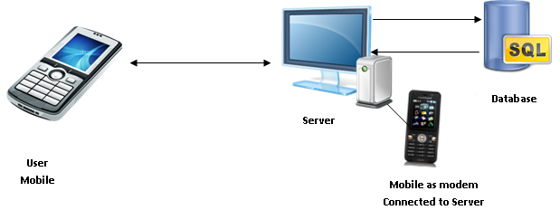
Fig 1. OVERVIEW OF COMMUNICATION SYSTEM

- User mobile: Used to compose the SMS and send to the receiver.
- Server: Receives the SMS in terms of mail and processes it.
- Mobile as modem: Acts as a modem which in turn sends the SMS to the receiver.
- Database: Used to store all the user details, sent mails, received mails and the timings.
- PROPOSED SYSTEM

This System will provide a service to facilitate to sending a message from mobile phone to E-mail accounts. This system will be based on various categories viz. Sender, E-mail-ids, Administrator. Further the Admin can personnel can add/update/remove the resources and the resource users from the system & mail server. The System should reflect and support this decentralized structure. A provision should further be allowed to add a new user. The System will also have an Admin who has full-fledged rights with regards to managing resources across system. The sender sends the messages through the mobile phones to the E-mail-ids. This service delivers a new type of network appliance and new level of functionality. MOBILE E-MAIL SERVICES VIA SMS will evolve messaging from the mobile phone to a complete communications medium. MOBILE E-MAIL SERVICES VIA SMS is a mobile e-mail client that manages sending an e-mail from the mobile phones to any user mail id. It conquers all the flaws of the existing traditional way of sending e-mail. It provides the unique functionality of efficiently sending e-mail along with reducing the sending time. MOBILE E-MAIL SERVICES VIA SMS can be used on all mobile phones which support SMS facility. The chief motive of this project is to make the services of an e-mail client to become available even on low cost mobile handsets which otherwise is available only on a very few high end cell phones.
It aims at enabling users to deal with their e-mail with minimal technical knowledge with the help of SMS facility. The goal of this project is to enhance mobile e-mail client with the features that give the user the possibility to fully control his e-mails, send e-mails from any mobile handset to any user which is having an e-mail account on any mailing website.
This System will provide a service to facilitate to sending a message from mobile phone to E-mail accounts. This system will be based on various categories viz. Sender, E-mail-ids, Administrator. Further the Admin can personnel can add/update/remove the resources and the resource users from the system & mail server. The System should reflect and support this decentralized structure. A provision should further be allowed to add a new user. The System will also have an Admin who has full-fledged rights with regards to managing resources across system. The sender sends the messages through the mobile phones to the E-mail-ids. This service delivers a new type of network appliance and new level of functionality. MOBILE E-MAIL SERVICES VIA SMS will evolve messaging from the mobile phone to a complete communications medium.
This System will provide a service to facilitate to sending a message from mobile phone to E-mail accounts. This system will be based on various categories viz. Sender, E-mail ids, Administrator. Further the Admin can personnel can add/update/remove the resources and the resource users from the system & mail server. The System should reflect and support this decentralized structure. A provision should further be allowed to add a new user. The System will also have an Admin who has full-fledged rights with regards to managing resources across system. The sender sends the messages through the mobile phones to the E-mail ids. This service delivers a new type of network appliance and new level of functionality. MOBILE E-MAIL SERVICES VIA SMS will evolve messaging from the mobile phone to a complete communications medium.

- MOBILE COMMUNICATION SYSTEM

With an estimated 3 billion people worldwide taking advantage of SMS messaging and text messages, this convenient mode of communication has more than caught on. Taking advantage of its freedom, speed and affordability, however, does have some prerequisites. To send SMS messages worldwide, people traditionally have needed mobile phones with appropriate service packages. Taking advantage of this facility which is free now a day we are developing our system. Electronic mail, commonly called e-mail or e-mail, is a method of exchanging digital messages from an author to one or more recipients. Modern e-mail operates across the Internet or other computer networks. Some early e-mail systems required that the author and the recipient both be online at the same time, in common with instant messaging. Today's e-mail systems are based on a store-and-forward model. E-mail servers accept, forward, deliver and store messages. Neither the users nor their computers are required to be online simultaneously; they need connect only briefly, typically to an e-mail server, for as long as it takes to send or receive messages.
An e-mail message consists of three components, the message envelope, the message header, and the message body. The message header contains control information, including, minimally, an originator's e-mail address and one or more recipient addresses. Usually descriptive information is also added, such as a subject header field and a message submission date/time stamp. In the existing system, user can send any multimedia to any other user. The user can send e-mails to many users at the same time by adding their e-mail id’s in address field. Each time the user has to login with the valid username and password whenever he wants to send or receive e-mails. Short Message Service (SMS) is the text communication service component of phone, web or mobile communication systems, using standardized communication protocols that allow the exchange of short text messages between fixed line or mobile phone devices. SMS text is the most widely used data application in the world, with 2.4 billion active users, or 74% of all mobile phone subscribers. SMS as used on modern handsets was originated from radio telegraphy in radio memo pagers using standardized phone protocols and later defined as part of the Global System for Mobile Communications (GSM) series of standards in 1985 as a means of sending messages of up to 160 characters, to and from GSM mobile handsets. The E-mail system is a service that is provided by a network application known as ‘mail server’. The mail Server is software that provides all functions of handling mails in the network. SMS messages can be sent from mobile devices, or they can be sent from computers by means of an SMTP application interface (for programmatic content delivery from application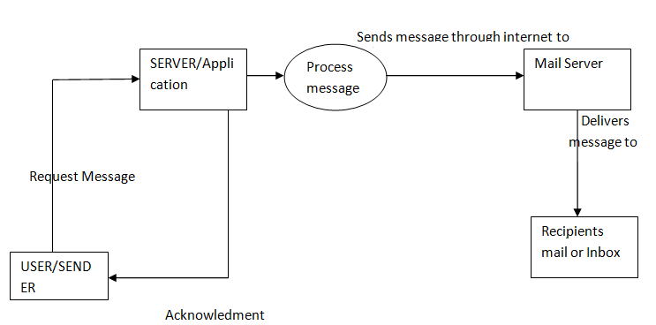
Fig 2 SYSTEM ARCHITECTURE
- SIMPLE MAIL TRANSFER PROTOCOL

SMTP is a connection-oriented, text-based protocol in which a mail sender communicates with a mail receiver by issuing command strings and supplying necessary data over a reliable ordered data stream channel, typically a Transmission Control Protocol (TCP) connection. An SMTP session consists of commands originated by an SMTP client (the initiating agent, sender, or transmitter) and corresponding responses from the SMTP server (the listening agent, or receiver) so that the session is opened, and session parameters are exchanged. A session may include zero or more SMTP transactions. An SMTP transaction consists of three command/reply sequences (see example below.) They are:
MAIL command, to establish the return address, a.k.a. Return-Path, 5321. From, mfrom, or envelope sender. This is the address for bounce messages.
RCPT command, to establish a recipient of this message. This command can be issued multiple times, one for each recipient. These addresses are also part of the envelope.
DATA to send the message text. This is the content of the message, as opposed to its envelope. It consists of a message header and a message body separated by an empty line. DATA is actually a group of commands, and the server replies twice: once to the DATA command proper, to acknowledge that it is ready to receive the text, and the second time after the end-of-data sequence, to either accept or reject the entire message.
Besides the intermediate reply for DATA, each server's reply can be either positive (2xx reply codes) or negative. Negative replies can be permanent (5xx codes) or transient (4xx codes). A reject is a permanent failure by an SMTP server; in this case the SMTP client should send a bounce message. A drop is a positive response followed by message discard rather than delivery.
The initiating host, the SMTP client, can be either an end-user's email client, functionally identified as a mail user agent (MUA), or a relay server's mail transfer agent (MTA), that is an SMTP server acting as an SMTP client, in the relevant session, in order to relay mail. Fully capable SMTP servers maintain queues of messages for retrying message transmissions that resulted in transient failures.
A MUA knows the outgoing mail SMTP server from its configuration. An SMTP server acting as client, i.e. relaying, typically determines which SMTP server to connect to by looking up the MX (Mail eXchange) DNS resource record for each recipient's domain name. Conformant MTAs (not all) fall back to a simple A record in case no MX record can be found. Relaying servers can also be configured to use a smart host.
An SMTP server acting as client initiates a TCP connection to the server on the "well-known port" designated for SMTP: port 25. MUAs should use port 587 to connect to an MSA. The main difference between an MTA and an MSA is that SMTP Authentication is mandatory for the latter only.

- ARCHITECTURAL DESIGN

Architectural design is a creative process where you try to establish a system that will satisfy the functional and non-functional requirements. Architecture of a software system may be based on a particular architecture model of style. Architecture models show the principle sub-system that make up the system.

System design

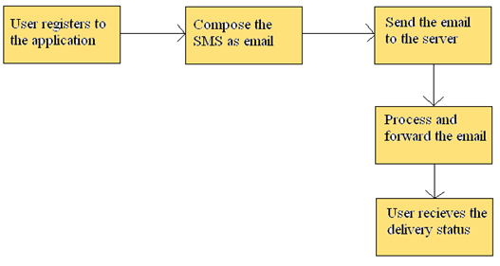

- Register: Users register with their Uname, mobile number and email id to this application.
- Compose Mail: Users compose the mails that are to be sent to the sender.
- Send mail: Composed mail is sent to the respective receiver.
- Process the mail: Composed mail is processes before it is sent to the receiver.
- Receive the mail: Receiver receives the mail.

Subsystem design

Subsystem design for user registration
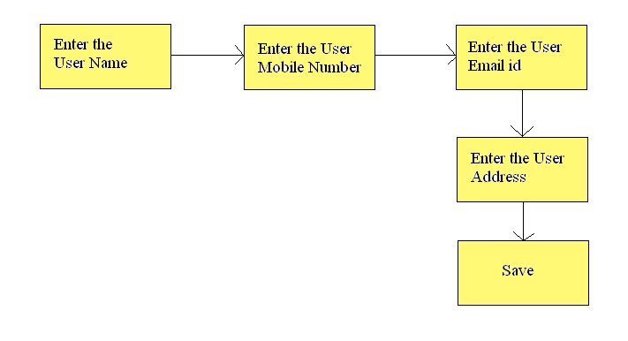
- Uname: User enters his/her user name.
- Mobile number: User enters his/her mobile number for the registration.
- Email id: User enters his/her email id in order to register to the application.
- User address: The user enters the address field which contains the sub fields like street and the city.
- Save: In the last step of registration the user saves the data he entered.

Subsystem design for composing the SMS as email

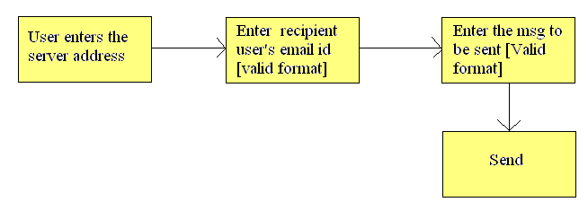
- Server address: The user enters the server address to connect to the intended Recipient.
- Recipient’s mail id: The user enters the recipient’s mail id in the valid format in the To address field.
- Compose message: Compose the message to be sent to the recipient.
- Sending: The composed mail is sent to the recipient.

Subsystem design for processing and forwarding of an email

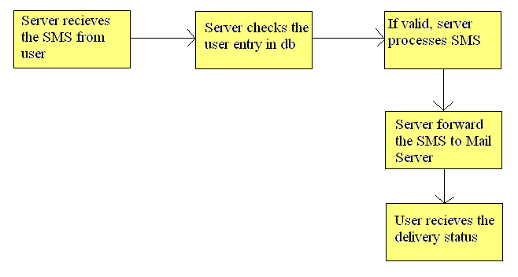
- Server receiving the SMS: The server receives the SMS from the user which he has composed.
- Checking the user entry: Server checks for the user entry in the database if he/she is a valid user.
- Process the SMS: The server then processes the SMS for forwarding it to the receiver
- Mail server: Server/modem forwards the SMS to the mail server which in turn sends it to the receiver.
- Delivery status: The user then receives the delivery status of the message that he/she has received.

- APPLICATION AREAS

- Enabling users to deal with their e-mail with minimal technical knowledge with the help of SMS facility.
- Enhance mobile e-mail client with the features that give the user the possibility to fully control his e-mails, send e-mails from any mobile handset to any user which is having an e-mail account on any mailing website.
- To make the services of an e-mail client to become available even on low cost mobile handsets which otherwise is available only on high end cell phones.

- CONCLUSION

This System provides a service that facilitates sending of an E-mail via SMS with the help of a mobile phone to any user having an E-mail id. This application is available not only on high end cell phones but also on low cost mobile handsets which provide the SMS facility. Allows fast and ease of sending E-mail from any remote location to any user. This system saves the time of the sender by sending an E-mail in less time and in reliable a manner. Though the E-mail sent by the sender is received by the intended recipient only, this system provides a high security and privacy among two users

REFERENCES
[1] Pahlavan, Kaveh; Krishnamurthy, Prashant (2002). Principles of Wireless Networks - a Unified Approach. Prentice Hall. ISBN 0130930032
[2] Loshin, P (1999). Essential Email Standards: RFCs and Protocols Made Practical. John Wiley & Sons. ISBN 0471345970.

[3] G. Castellano, A. M. Fanelli, M. A. Torsello. “SMS integration techniques”. IADIS International Conference Applied Computing 2007, pg 371-378.

[4] José Roberto de Freitas Boullosa. "An Architecture for Web design approach".

[5] Yan Wang.” SMS alert and Knowledge Discovery of Usage Patterns”. CS 748T Project. February, 2000.

[6] www.wikipedia.com

